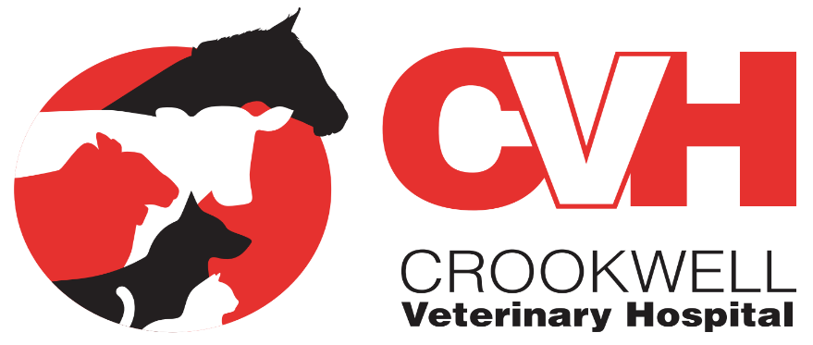
Covid-19 Update

Covid-19 is causing a large amount of concern and uncertainty in communities, including ours.

What is a coronavirus?
- Coronaviruses is a group of viruses that infect birds and mammals, including humans.
- In humans they are often associated with the common cold, bronchitis and pneumonia, they can also affect the gut.
- Two coronaviruses we see as vets are Canine and Feline coronavirus which cause diarrhoea. They do not cause infections in humans
  - They are not associated with the current COVID-19 pandemic.

Can Covid-19 infect pets?
- There have been reports of a dog in Hong Kong that was tested positive to COVID-19 from oral and nasal swabs. This dog was owned by a person with COVID-19 and would have transmitted it from the owner.
  - The first blood results from the dog are negative.
  - The dog has also shown no symptoms
- At this stage there is no evidence of pet dogs or cats as a source of infection.

As a valued client we would like to reassure you that we are taking the situation seriously and are putting in place a number of precautions to protect both you and our staff as well as still providing the highest level of care to our patients.

At this stage we are remaining open as normal and will continue to provide a 24hr emergency service.

Following the steps below will help us greatly in assisting you and your pet in the safest way:
- Please phone to make a consultation 02 4832 1997
- Tell us;
  - If you have been in the ACT since the 5th of August
  - If you have been in a COVID HOT SPOT
  - If you are under a STAY AT HOME ORDER
  - If you are experiencing symptoms such as a sore throat, dry cough or fever
  - If you need to self-isolate
- By doing this we can give advice and if need be make alternative arrangements.

- In line with social distancing guide lines we aim to keep waiting times to a minimum
  - By not phoning to make a consultation it makes it difficult to achieve this and you may be asked to leave and return at a later time.
When coming to the veterinary hospital we ask you to:
- Wear a face mask
- Sign in using the QR code or if you are not able to use the QR codes ask one of our staff members to sign you in manually.
- Limit the number of people presenting your pet to just one owner/person
- At the front desk there is hand sanitiser for your use, please use when entering the hospital.
If you require medication repeats please phone ahead so we can have them ready for you to pick up without the wait, this includes sedation for rams.
Thank you for your understanding in the difficult and unprecedented times for your cooperation. We will aim to keep you up to date as the situation evolves as required.

If you have any questions please contact us on 02 4832 1977.

Crookwell Veterinary Hospital
220 Goulburn St,
Crookwell NSW 2583
02 48321977
www.crookwellvet.com.au
Find us on Facebook

